29 November 2018

STAHL CraneSystems GmbH
Daimlerstraße 6
74653 Künzelsau

Your contact for questions on the content: Author:
Heike Metzger Daniela Peuckert
Tel. +49 7940 128-2388 VISUELL Studio für Kommunikation
Fax +49 7940 128-2300 Tel. +49 711 64868-0
heike.metzger@stahlcranes.com daniela.peuckert@visuell.de
www.stahlcranes.com

Strong giant on delicate assignment
Hoists from STAHL CraneSystems help with dismantling logistics at Philippsburg nuclear power plant

With the 13th amendment of the Atomic Energy Act in the summer of 2011, it was decided that Germany would move away from use of nuclear power as a source of energy. All nuclear power stations in Germany are to be decommissioned by the end of 2022. The shutdown and subsequent dismantling present a logistical challenge to the operators. Tonnes and tonnes of material have to be removed and dismantled, relocated and moved. Strong technology from STAHL CraneSystems is also being used in Philippsburg for this.

The Philippsburg nuclear power plant (NPP) operated by EnBW is located on the right bank of the Rhine at river kilometre 389. The boiling water reactor in Unit 1 of the nuclear power plant (NPP 1) was, after 32 years of operation, one of the first eight reactors to be taken from the grid in the course of the energy turnaround in 2011. In May 2017, after completion of the approval process, dismantling of this plant began. The pressurised water reactor in Unit 2 (NPP 2) is also approaching the end of its operating life and will be shut down by the end of 2019 at the latest.

The highly radioactive spent fuel elements of the two reactors have been stored in suitable containers in the interim storage facility of the NPP since 2007 and are not affected by the dismantlement. Of the total mass of an EnBW nuclear power plant, up to 98% are conventional reusable and raw materials and 1-3% are low to medium-level radioactive residues. The total mass of the nuclear power plant NPP 1 is approximately 398,000 tons, that of NPP 2 approximately 783,000 tons. EnBW is putting a special dismantling infrastructure in place to enable efficient handling of these masses: a residue processing centre (RPC) for the treatment of residues and a waste storage facility (WSF) in which the radioactive waste will be stored until the permanent disposal site “Schacht Konrad” near Salzgitter is commissioned are being erected on the premises of the nuclear power station.

In January 2017, EnBW contracted Innokran GmbH, a certified partner of STAHL CraneSystems, to install three crane systems in the Philippsburg residual waste processing centre and waste storage facility. “We completed our first job in the power plant sector back in 2012 and have continuously expanded our experience in this field,” explains Christoph Fischer, Managing Director of Innokran.

A frequency-controlled SHWF 8 winch from STAHL CraneSystems with a lifting capacity of 32 tonnes is being used in the RPC on a double girder overhead travelling crane with a span of 20 metres. The SHW 8 winch from STAHL CraneSystems is based on the tried-and-tested SH wire rope hoist programme and is designed for the high-load bracket up to 160,000 kg. Thanks to its robust and low-maintenance design, it is ideally suited to everyday work. The modular assembly of the winch enables various designs and trolley variants, opening up a wide range of possible applications and solutions tailored to specific requirements. The SHWF 8 winch in Philippsburg has a lifting speed range from 0 to 4 m/min. and is continuously variable. In addition, an auxiliary SHF 50 hoist with a lifting capacity of 5 tonnes has also been installed. The power supply lines for the hoists each run protected in an energy chain. When the load moves downwards, the generator-generated energy is converted into heat by the braking resistance and can be released into the environment by convection. In addition, the special safety standards applicable in nuclear technology require redundant implementation of brakes and measuring systems. Some components, such as the switch cabinet, are made of corrosion-free stainless steel for easier cleaning; a paint coating is not required.

“The biggest challenge with such a plant is the complete documentation of all work processes – also those of supplier companies. EnBW attaches great importance to this,” says Christoph Fischer. For example, all steel components must be marked with material stamps to ensure traceability. After the preliminary test has been carried out, the components are joined according to a welding plan. Before painting, all material stamps are compared and the execution of the welds, dimensional accuracy and completeness are inspected by external inspectors.

EnBW is also constructing a residue processing centre and waste storage facility in a similar manner at its Neckarwestheim site. Three Innokran crane systems will also be used there.

Characters: 4,579 (incl. blanks)

Photos:
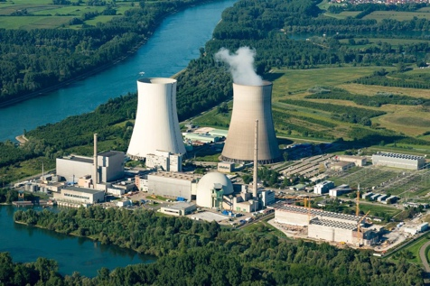
The Philippsburg nuclear power plant
(Photo credit: EnBW)

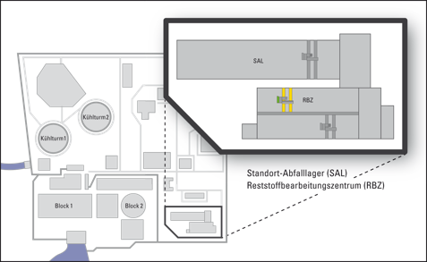
The Philippsburg nuclear power plant with residue processing centre (RPC), where the SHWF 8 winch from STAHL CraneSystems works.

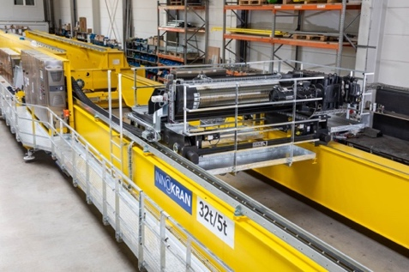
The power supply lines for the 32 t SHWF 8 winch and the auxiliary 5 t winch each run protected in an energy chain.

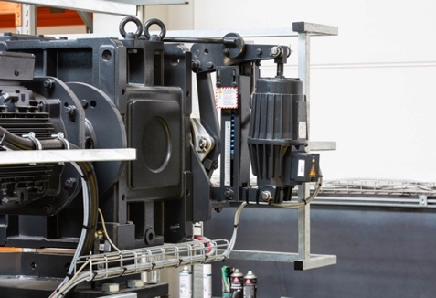
The second hoist brake is an additional double-shoe brake according to DIN 15435 with external brake spring.

The switch cabinet is made of corrosion-free stainless steel, a paint coating is not required.

