27 January 2018

STAHL CraneSystems GmbH
Daimlerstraße 6
74653 Künzelsau

Your contact for questions on the content: Author:
Heike Metzger Clara Ketterer
Tel. +49 7940 128-2388 VISUELL Studio für Kommunikation
Fax +49 7940 128-2300 Tel. +49 711 64868-0
heike.metzger@stahlcranes.com clara.ketterer@visuell.de
www.stahlcranes.com

There’s more than silk in Kashmir
STAHL CraneSystems supports major project in the Himalayas

“If there is paradise on Earth, it is here,” the Mughal emperor Jahangir once said four centuries ago in describing the landscape of the northern Indian state of Jammu and Kashmir. Lying at the foot of the Himalayan massif, the small region is host to a variety of climate zones: from temperate and mediterranean to subtropical and high alpine. The diversity of the climate and soil conditions forms the basis for the existence of a wide range of different plant and animal life. The idyllic countryside attracts countless trekkers every year and even filmmakers from Bollywood use the splendid setting for their productions.
To please the demands of guests for comfort and the like, a lot is being invested in India. One of the projects is the Kishanganga hydroelectric power plant that was built near the town of Bandipora on the fringes of the frontier between Pakistan and India. It is part of a large hydroelectric power station programme being implemented by the state-owned Indian power utility NHPC Ltd. (formerly National Hydroelectric Power Corporation). NHPC is being supported in its plans by the German engineering firms DSD NOELL GmbH and STAHL CraneSystems as well as by the Hindustan Construction Company from India.

The Kishanganga hydroelectric power plant lies 2,400 metres above sea level. At these altitudes, temperatures from November to May are icy cold. In the summer months, by contrast, landslides make the region difficult to access. Not least for these reasons, the customer NHPC Ltd. sought strong partners able to guarantee punctual delivery and reliable execution of the work. DSD NOELL GmbH from Würzburg and STAHL CraneSystems from Künzelsau stood the test of these high requirements.
To ensure continuous operation of the turbine generators of the Kishanganga hydroelectric power plant, which are meant to generate a total of 330 megawatts of electricity, it is vital that a continuous flow of water is ensured. The plan to guarantee this: to dam the Kishanganga River. As a specialist in the field of hydraulic steel structures in waterways, weirs and hydroelectric power stations, DSD NOELL GmbH planned and built a 37 m high weir. STAHL CraneSystems, a specialist in crane technology with the largest range of high-quality hoisting technology available worldwide, developed and delivered the winch system to lower the 100 t sluice.

The demands on the hoist were high as it had to work reliably in the adverse environmental conditions in the mountainous region. The first concepts for the custom solution were developed at the headquarters of STAHL CraneSystems in Künzelsau back in 2009: a stationary SHW 8 winch with a safe working load of 2 x 60,000 kg consisting of two rope drums and a gearbox. To ensure equal distribution of the weight, the hoist was designed in reeving of 2 x 12/2-1 and the drum manufactured in a length of L4. The final height of lift achieved after completion was 21.5 m at 2 x 150 m rope length. Thanks to double symmetrical arrangement of the reevings, it was possible to realise perfect synchronism of the two load hooks. The total length of the winch system covers almost
9 m.
The rope drums are flanged to the gearbox with special couplings, thereby compensating all tolerances between the machine and steel structure. Due to local conditions, the gear motor is mounted vertically. As a result of this unusual assembly, the hoist motor is mounted above one of the two rope drums.

To ensure safe lowering of the sluice, the engineers from STAHL CraneSystems implemented the rope with seven-fold safety. In addition to that, they included a second brake in the winch system as safety brake, flanged directly on to the gearbox. The hoist was equipped with an overload cut-off device for each of the two load hooks and placement of the load realised separately through slack rope cut-off for each of the two hooks. Both of the current hook positions are shown as optional extra on a display on the switch cabinet doors. In addition to that, the motor currents of the hoist motor are shown on ammeters. This hoist motor is additionally protected by motor circuit-breakers.
The hoist is designed for its application for an ambient temperature between –25 °C and +40 °C. Robust, pole-changing technology with further tolerance ranges enables operation in unstable mains power supplies. An external ventilation with stopping control was implemented in the hoist motor to ensure a 15-minute duty for the hoisting technology with a subsequent cooling phase. The winch system was given a special finish of a 270 µm thick top coat of polyurethane to make it weatherproof. Due to the air humidity, STAHL CraneSystems also equipped the panel boxes and hoist motor of the individual hoists with a heater. A hoist brake with built-in brake venting lowers the load with pauses in the event of a power failure. The weight of the load is determined continuously by the SMC multi-controller via analogue measuring sensors. In the case of an overload, the lifting movement is switched off immediately. The multi-controller can, moreover, measure further data such as, for example, the load spectrum, the operating time, the full-load operating time and the motor switching operations and read them out with the help of a PC.

The performance of the winch was put to test at Haslinger GmbH Metallbau + Krantechnik, a certified partner of STAHL CraneSystems, at the end of September 2011. With its “partner of” concept, STAHL CraneSystems has been pursuing a strategy of separating crane building and crane technology from each other successfully since 2009. In this strategy, competent crane builders see to planning and production of the crane systems, while STAHL CraneSystems concentrates on the development and production of hoists and crane technology of world-class standard. Haslinger GmbH Metallbau + Krantechnik, one of the most important partners of STAHL CraneSystems in Germany, manufactured the steel portal including ladders, walkways, framework construction for the winch systems and the enclosure for the hoisting technology for the project in the Himalayas.
Following successful testing, the hoisting technology with crane system was transported to the installation site more than 5.5 thousand kilometres away.

Construction work on the Kishanganga River had almost been completed at this time: the weir, which passes a part of the river into a newly constructed riverbed, was built in autumn 2016. The remaining water is used to supply the hydroelectric power plant continuously. It is first collected from the reservoir in an equalizing reservoir through a 24-kilometre long tunnel before it is passed to the underground power station with three Pelton turbines. Each of the turbines generates a power of 110 MW.

The crane system was commissioned on site by the STAHL CraneSystems factory service centre. Since the passes in the Himalayas are only passable for a few weeks in summer, the equipment had to be delivered in a finely defined period of time. The moment came at long last in mid-July this year: the sluice was lowered with the help of the special winch. Since then, the reservoir has been filling up day for day. The minimum draw down level (MDDL) was already reached in mid-August. The Kishanganga hydroelectric power plant is set to go online in 2018.

Despite delays due to the impassable terrain and unrest in the nearby border to Pakistan, all companies involved in the project and the customer NHPC Ltd. are satisfied with the progress in this project, which represents a further step in the development of the region Jammu and Kashmir.

Characters: 7,936 (incl. blanks)
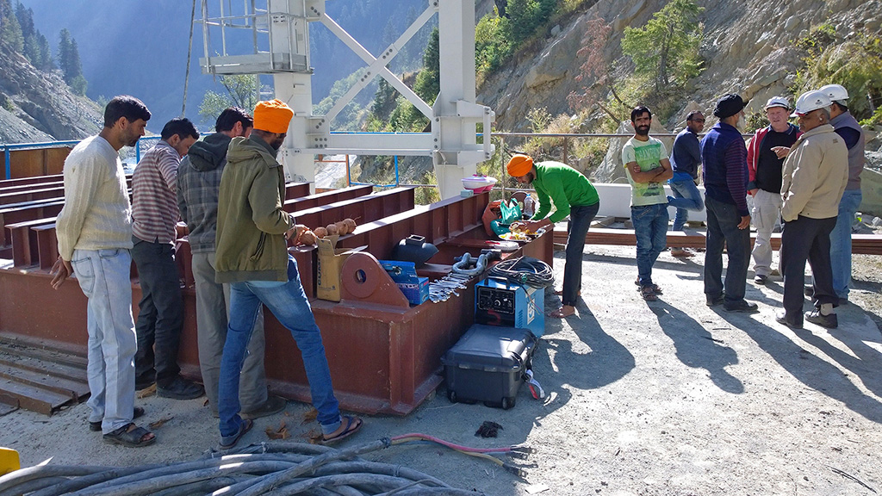  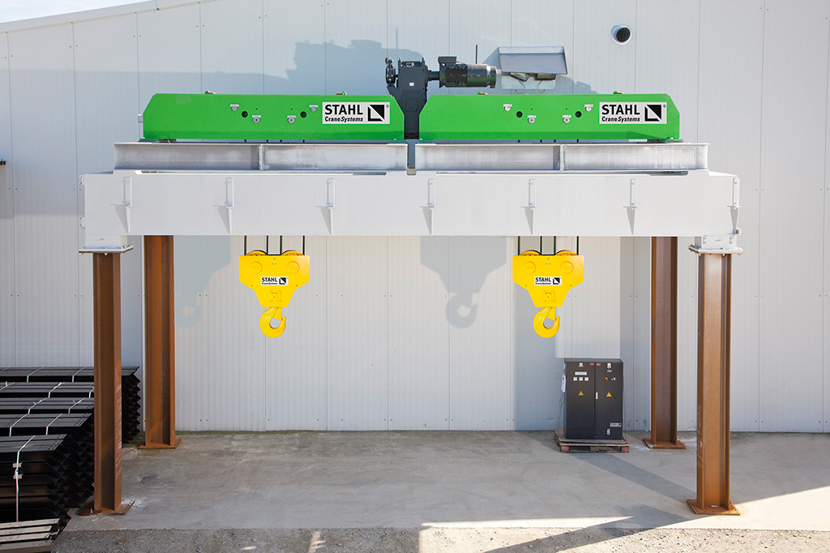 | Test set-up of the SHW 8 special winch from STAHL CraneSystems: the gear motor was mounted vertically and the hoist motor above one of the two rope drums.  Arrival of the crane system in the Himalayas at 2,400 metres above sea level.
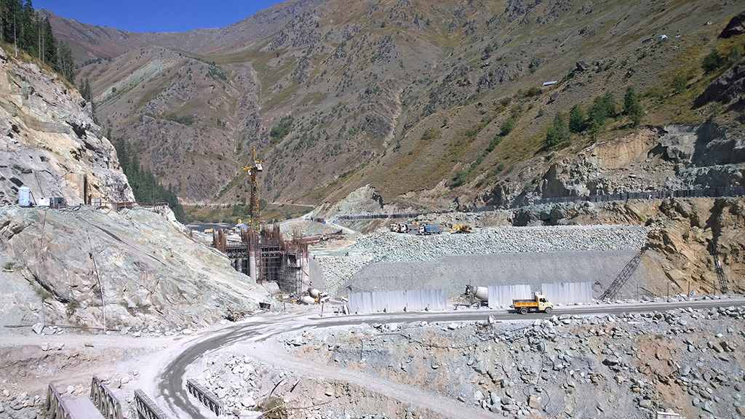  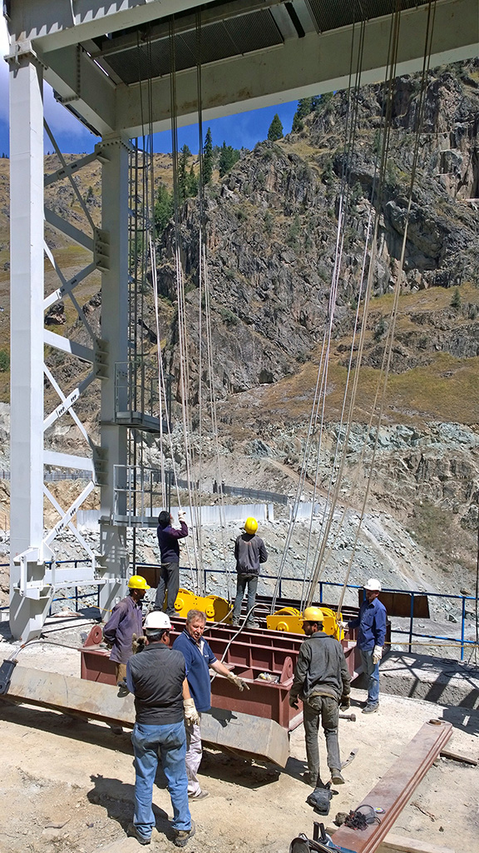 | The factory service centre of STAHL CraneSystems and installation personnel from DSD NOELL join forces to commission the hoisting technology.  Yesterday building site, today dam – work on the Kishanganga River in the Himalayas.
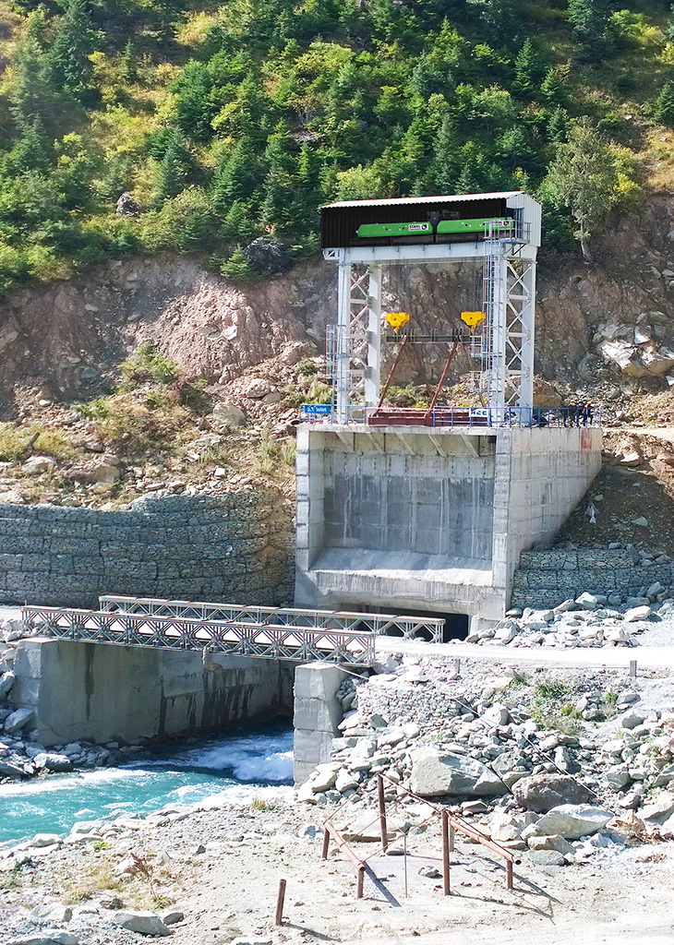  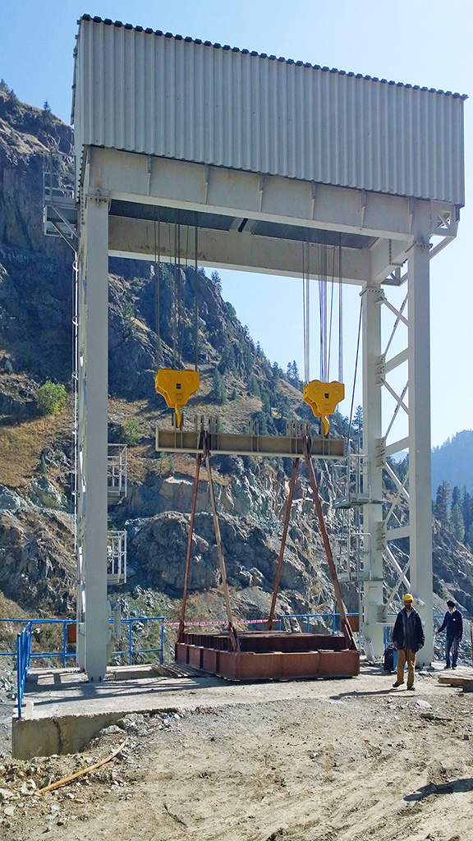  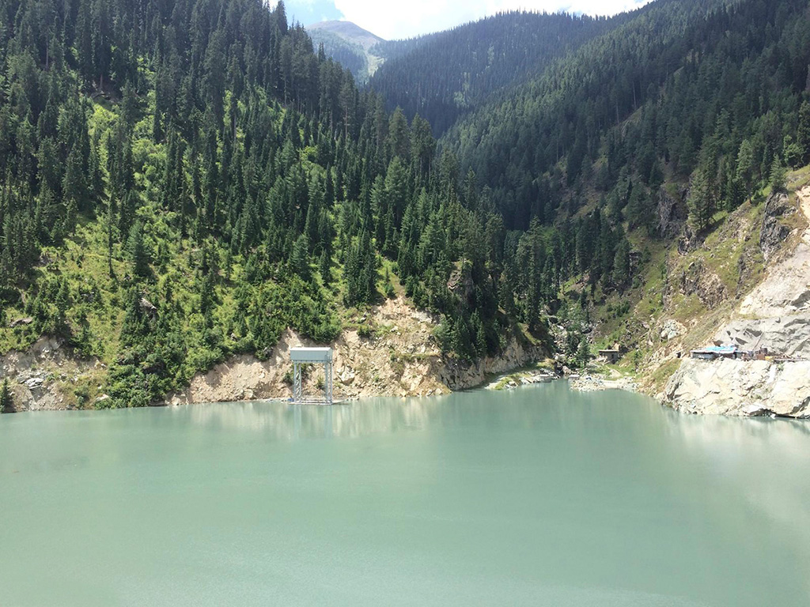 | The protective enclosure of the hoisting technology from STAHL CraneSystems was manufactured by its certified partner Haslinger GmbH Metallbau + Krantechnik  View of the river diversion and hoisting technology from STAHL CraneSystems  The dam in August 2017: the water level rose to the minimum draw down level (MDDL) within a month.

